**Experiment 3.2**

**Student Name: Sahul Kumar Parida UID: 20BCS4919**

**Branch: CSE Section/Group: WM 904/B**

**Semester: 5th Date of Performance: 02/11/22**

**Subject Name: Machine Learning Lab Subject Code: CSP-317**

**1. Aim/Overview of the practical:**

To implement Principle Component Analysis.

# 2. Task to be done:

# Step 1: Importing the required libraries.

# Step 2: Preparing the data.

# Step 3: Preparing the target data.

# Step 4: Applying it to PCA function.

# Step 5: Creating a Pandas DataFrame of reduced Dataset.

# Step 6: Concat it with target variable to create a complete Dataset.

# 3. Apparatus/Simulator used:

* Jupyter Notebook/Google Collab
* The IRIS dataset is a collection of data that is used to demonstrate the properties of various statistical models. It contains information about 50 observations on four different variables: Petal Length, Petal Width, Sepal Length, and Sepal Width.

**4. Code and Output:**

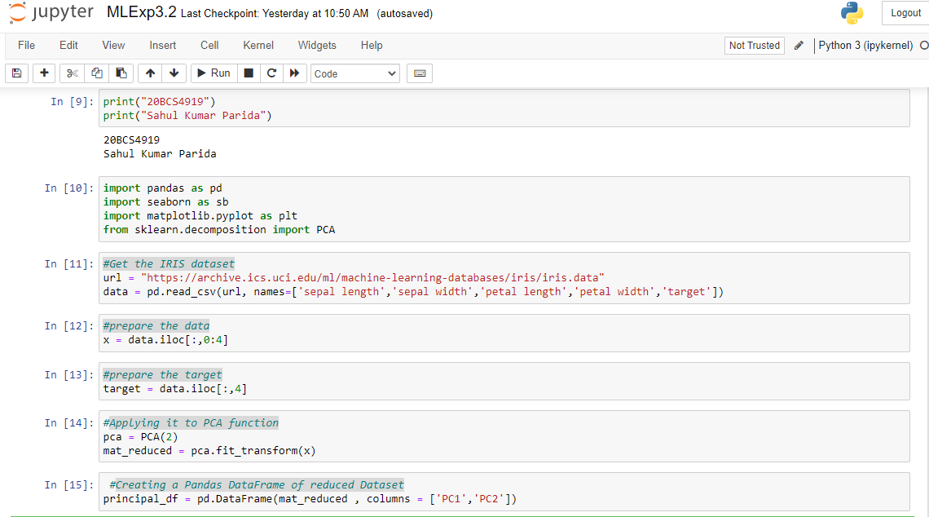

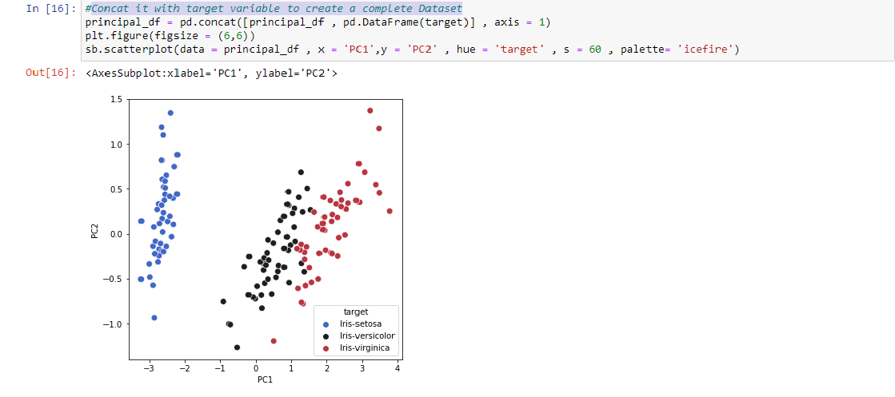

**Learning outcomes (What I have learnt):**

1. Learning about different library/packages of python.
2. Learning about the different methods, that are needed to analyze the given dataset.
3. Learning about different Machine Learning Functions.
4. We learn to split data into training and testing datasets.
5. Implementation of Principle Component Analysis(PCA).